**DAILY ONLINE ACTIVITIES SUMMARY**

|  |  |  |  |  |  |  |  |  |
| --- | --- | --- | --- | --- | --- | --- | --- | --- |
| **Date:** | **26/06/20** | | | | | **Name:** | **SARANG VK** | |
| **Sem & Sec** | **8th B** | | | | | **USN:** | **4AL16CS085** | |
| **Online Test Summary** | | | | | | | | |
| **Subject** | | **…….** | | | | | | |
| **Max. Marks** | | **……..** | | **Score** | | | **……..** | |
| **Certification Course Summary** | | | | | | | | |
| **Course** | **Python for Machine Learning** | | | | | | | |
| **Certificate Provider** | | | **GREATLEARNING** | | **Duration** | | | **28 MINUTES** |
| **Coding Challenges** | | | | | | | | |
| **Problem Statement: : : Java coding problem** | | | | | | | | |
| **Status:COMPLETED** | | | | | | | | |
| **Uploaded the report in Github** | | | | | **YES** | | | |
| **If yes Repository name** | | | | | **alvas-education-foundation/sarang_vk** | | | |
| **Uploaded the report in slack** | | | | | **YES** | | | |

Certification Course Details: (Attach the snapshot and briefly write the report for the same)

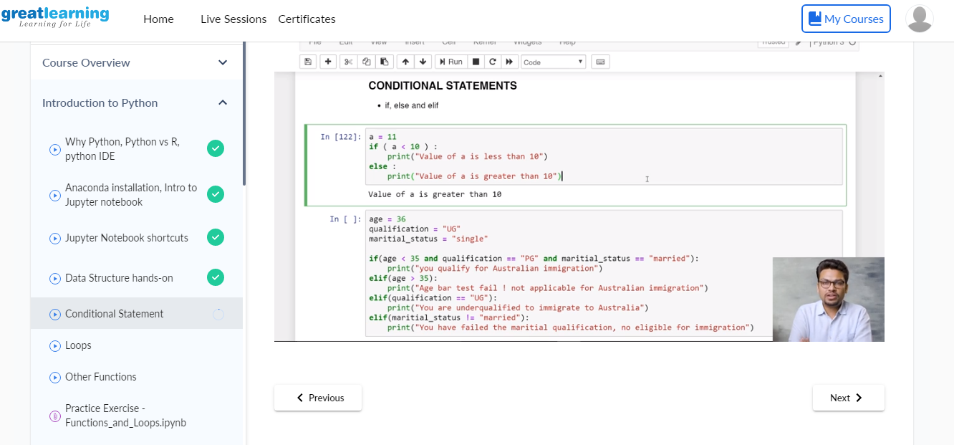

Coding Challenges Details: (Attach the snapshot and briefly write the report for the same)

Coding was given and it was uploaded for github and slack

Program no:1

public class ReverseList {

    //Represent a node of the doubly linked list

    class Node{

        int data;

        Node previous;

        Node next;

        public Node(int data) {

            this.data = data;

        }

    }

    //Represent the head and tail of the doubly linked list

    Node head, tail = null;

    //addNode() will add a node to the list

    public void addNode(int data) {

        //Create a new node

        Node newNode = new Node(data);

        //If list is empty

        if(head == null) {

            //Both head and tail will point to newNode

            head = tail = newNode;

            //head's previous will point to null

            head.previous = null;

            //tail's next will point to null, as it is the last node of the list

            tail.next = null;

        }

        else {

            //newNode will be added after tail such that tail's next will point to newNode

            tail.next = newNode;

            //newNode's previous will point to tail

            newNode.previous = tail;

            //newNode will become new tail

            tail = newNode;

            //As it is last node, tail's next will point to null

            tail.next = null;

        }

    }

    //reverse() will reverse the doubly linked list

    public void reverse() {

        //Node current will point to head

        Node current = head, temp = null;

        //Swap the previous and next pointers of each node to reverse the direction of the list

        while(current != null) {

            temp = current.next;

            current.next = current.previous;

            current.previous = temp;

            current = current.previous;

        }

        //Swap the head and tail pointers.

        temp = head;

        head = tail;

        tail = temp;

    }

    //display() will print out the elements of the list

    public void display() {

        //Node current will point to head

        Node current = head;

        if(head == null) {

            System.out.println("List is empty");

            return;

        }

        while(current != null) {

            //Prints each node by incrementing the pointer.

            System.out.print(current.data + " ");

            current = current.next;

        }

    }

    public static void main(String[] args) {

        ReverseListdList = new ReverseList();

        //Add nodes to the list

        dList.addNode(1);

        dList.addNode(2);

        dList.addNode(3);

        dList.addNode(4);

        dList.addNode(5);

        System.out.println("Original List: ");

        dList.display();

        //Reverse the given list

        dList.reverse();

        //Displays the reversed list

        System.out.println("\nReversed List: ");

        dList.display();

    }